Nepal College of Information Technology
Unit Test
Spring 2010
Program : BE ELX Time : 2 hrs
Semester : Spring (II) FM : 70
Subject : Filter Design PM : 35

- Candidates are requested to give their answer as far as practicable in their own words.
- The figure in the margin indicates the full marks
- Attempt ALL question
1. a) Explain the different available filter design technologies .What are different factors to be considered while designing filters? [7]
b) Following circuit is a low pass filter designed at normalized frequency of w=1rad/sec. [8]
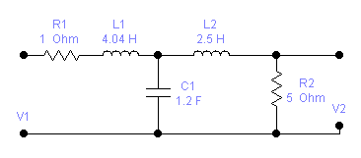
Apply frequency scaling so that the normalizing frequency is 10^4rad/sec and magnitude scaling to get realizable elements.
2. a) For the following specification of a LPF, calculate the order of Chebyshev filter.
α_{max=} 0.5dB, α_{min=} 22dB, w_{p}=1, w_{s}=2.33 [5]
b) Derive expression to find the order of Butterworth filter. [10]
OR
Derive expression to find the order of Chebyshev filter.
3. a) Compare Butterworth and Chebyshev responses. [5]
b) Find the Butterworth transfer function to meet the order n=4. Also find the half power frequency and the location of poles and zeros. [10]
4. a) Considering the delay response, which filter would you select among Butterworth, Bessel Thomson and Chebyshev and why? [5]
b) It is required to design a band stop filter with rejection band that extends from w=10⁵rad/s to w=4x10⁵rad/s. [10]
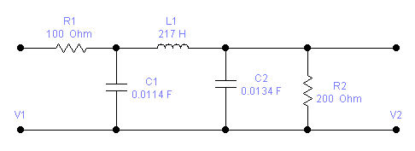
5. Write short notes on (any two) [5*2]
a) Group delay and phase delay
b) Importance of scaling
c) Positive Real Function

